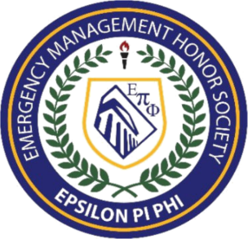
Epsilon Pi Phi
ACHIEVEMENT LEVELS

In addition to invitation into the Epsilon Pi Phi Honor Society, members can be recognized based on two levels of achievement that work in tandem with the curriculum for obtaining the Certified Emergency Manager certification (CEM). These levels are fundamental in recognizing students who are willing to go beyond general requirements and commit additional time and effort into their field.
Achievement Levels: Earned by members based on the completion of the following requirements:
An application fee is required for each achievement level application.

The Silver Level:

Note: This Level must be completed before you can apply for the Gold Level. There is a minimum 30 day waiting period between acceptance into the silver level and application submission for gold level.
Applications can be downloaded from the Foundation’s website

1. Have completed 1 of the following disaster/emergency management training.
- IS-5 A An Introduction to Hazardous Materials
- IS-42 Social Media in Emergency Management
- IS-120 An Introduction to Exercises
- IS-235 Emergency Planning
- IS-362 Multi Hazards Planning for Schools
- IS-775 EOC Management and Operations

2. Have completed 1 of the following general management training.
- IS 240-Leadership and Influence
- IS-241-Decision Making and Problem Solving
- Other approved management course (i.e.: Human Resources, Sociology, Psychology, etc.)

3. Have completed a minimum of 10 hours of volunteer service in an emergency management related capacity. An emergency management related organization is any public, private or not for profit organization with an emergency management focus. An example would be any VOAD, NVOAD, state or local EM agency, etc.

4. Have participated in a significant community service-learning project, which furthers the nations/communities knowledge concerning issues of disaster or emergency management. An example of such a project might include speaking to a group of grade students with the purpose of educating them about the nuances of what an emergency manager does.

5. Must contribute to the profession by completing your choice of at least one of the following
categories of professional contributions in the field of disaster/emergency management.

- Professional Conference. This category requires attendance at one professional conference, such as IAEM's annual conference or your state's emergency management annual conference. Other acceptable conferences are those hosted by national, state, regional or local agencies; schools; businesses; or industries with an emergency management role.

- Research – To satisfy this category, a candidate must have participated in a research project that contributes to the overall field of emergency management. The research should be available for peers, colleagues and students.

- Legislative Contact. To satisfy this category, a candidate must have contacted an elected official at the national or state level regarding an emergency management issue. While a personal visit can be very effective, a written letter works best here because of the documentation requirement.

